For unstable or oscillatory responses, the first order linear equation does not represent the input to output relationship in the data. Indicate any system responses that are not a good fit for this equation form.
Problem 1
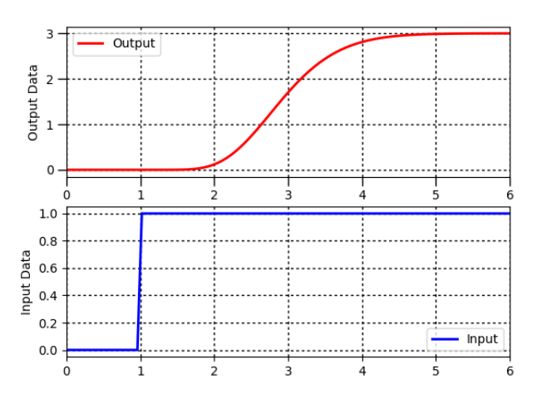
Solution
- Find Δy from step response = 3
- Find Δu from step response = 1
- Calculate Kp=ΔyΔu = 3 deg C/(kg/s)
- Find θp, apparent dead time, from step response = 1.2 sec
- Find 0.632Δy from step response = 1.9
- Find t0.632 for y(t0.632)=0.632Δy from step response = 3.1
- Calculate τp=t0.632−θp. = 3 – 2.1 = 0.9 sec

Problem 2

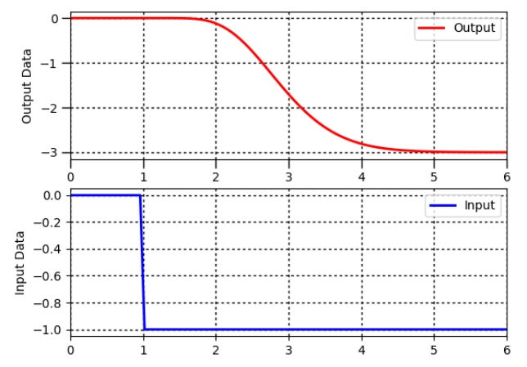
Solution
- Find Δy from step response = 3
- Find Δu from step response = 1
- Calculate Kp=ΔyΔu = 3
- Find θp, apparent dead time, from step response = 1.2 s
- Find 0.632Δy from step response = -1.9
- Find t0.632 for y(t0.632)=0.632Δy from step response = 3.2
- Calculate τp=t0.632−θp. = 3.2-2.1 =1.1
Kp = 3
Θp = 1.2 s
Τp = 1.1 s

Problem 3
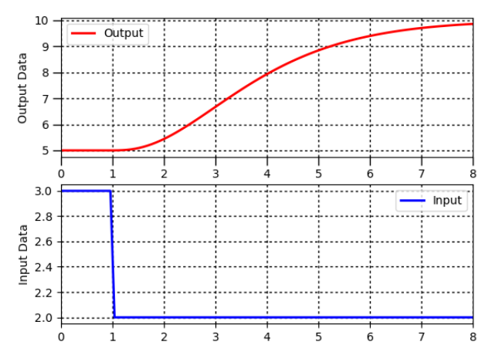

Solution
- Find Δy from step response = 5
- Find Δu from step response = 1
- Calculate Kp=ΔyΔu = 5
- Find θp, apparent dead time, from step response = 0.7 s
- Find 0.632Δy from step response = 8.2
- Find $t_{0.632}$ for y(t0.632)=0.632Δy from step response = 4.2
- Calculate τp=t0.632−θp. = 2.5
Kp = 5
Θp = 0.7 s
Τp = 2.5 s

Problem 4
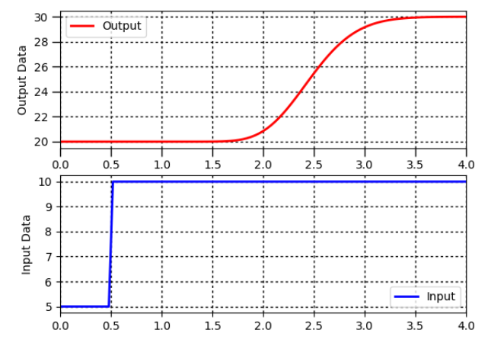
Solution

Δy = 10
Δu = 5
0.632* Δy = 6.32
$t_{0.632}$=2.6 s

Kp = 2
Θp = 1.5 s
Τp = 0.6 s

Problem 5
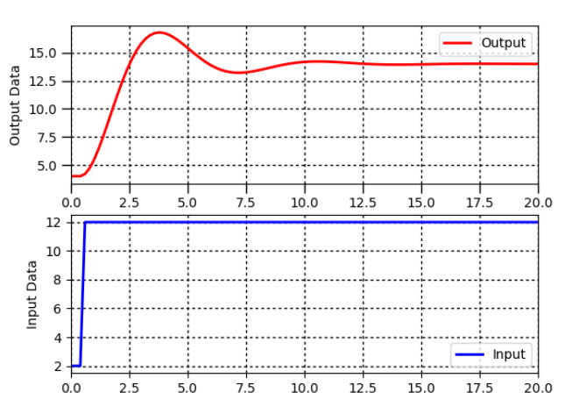

Solution

Δy = 12
Δu = 10
0.632* Δy = 8.9
$t_{0.632}$=

Kp = 1.2
Θp = 0.1 s
Τp = 2 s

Problem 6

Not applicable since the output never converges.

Problem 7
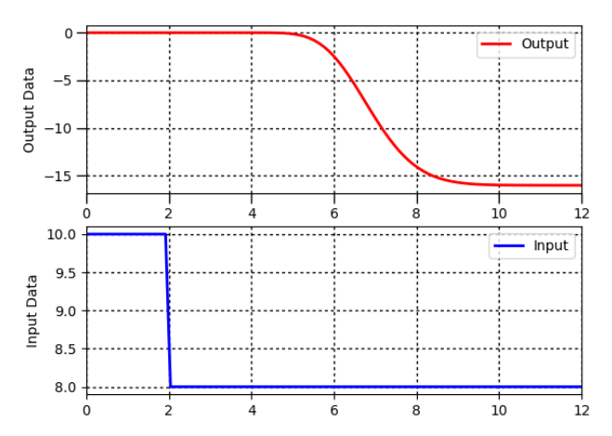

Solution

Δy = -16
Δu = -2
0.632* Δy = 10.1
$t_{0.632}$= 7.1 s

Kp = 8
Θp = 3.3 s
Τp = 7.1 – 5.3 = 1.8 s

